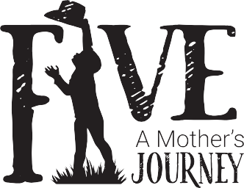

214 Bridgeford Blvd
Ridgeland, MS 39157
(p) 601-749-6729

awards
Tokyo International Monthly Film Festival/Tokyo
Honorable Mention

Lisbon Cinefest / Lisbon, Portugal
Nominee First Time Filmmaker

The Black Panther International Short Film Festival / Delhi India
Quarter Finalist First Time Director

Accolade Global Film Competition / California
Award of Recognitions African American Documentary Feature
www.brice-media.com
Liberation/Social Justice/Protest

Naples Film Awards/ Naples Italy
Feature Documentary

Andromeda Film Festival/Istanbul Turkey
Best Documentary

Ediplay International Film Festival/Paris France
Best Women’s Festival

Holidays365nInternational Film Festival/California
Best Documentary

World Film Carnival/ Singapore
Finalist/ Best Documentary

San Antonio Black International Film Festival
Nominee/Best Documentary

selected
Chicago Indie Film Award

Berlin International Film Festival New York Istanbul Short Film
Toronto International Women Film Festival

